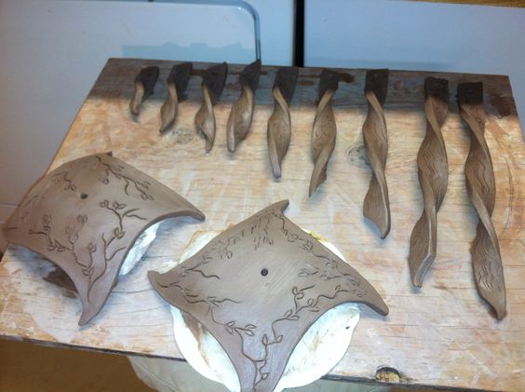 | Advanced Ceramics  Syllabus  Notre Dame Preparatory  Scottsdale, Arizona | 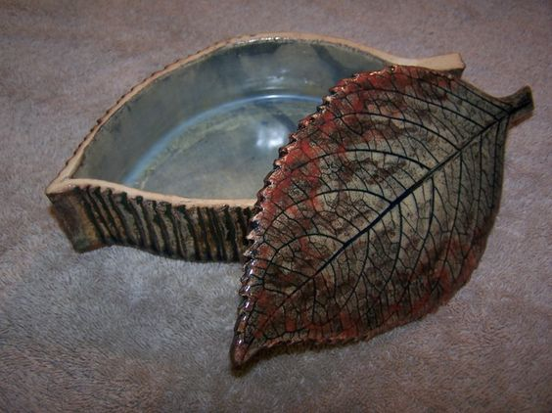

Length of Course: | 1 Semester
Number of Days/Week: | 5 Days
Number of Credits: | 1/2 Credit
Classroom/Studio | 405
Teacher | Mr. Ray Medhus

SUPPLIES
- Pocket folder - to hold CPR sheets. sketches, notes, and handouts
- Something to write with
- iPad and ear plugs
DESCRIPTION
Students will begin this class by reviewing and demonstrating the techniques they learned in Ceramics II. Because this class is by nature an advanced class, students are afforded the opportunity to work more independently. Students may choose to spend the semester working in one technique; wheel throwing or hand building. The Slab Roller can be used for many things, as can the extruder. New shapes and forms may be explored. Creating a diversity of sculptural pieces as it makes different shapes and forms. The Potter’s Wheel can be used to “throw” pots and make them symmetrical. Once mastered, the artist can create a large number of pieces that are similar in size and shape. The Slab Roller can be used to easily roll out large slabs of clay.
While the emphasis is to work in clay, students may include other materials that may be appropriate to the assignment. As in any form of art, the elements of design (line, shape, color, texture, space and form) and how these elements are used successfully will be discussed and will be part of the individual student grade. Craftsmanship and creativity will be emphasized and will be of great importance in the success of the student in this course.
Course Objectives:
- Review ceramic forms, both functional and decorative, by using basic hand building methods and expanding upon them to create larger and more challenging projects.
- Create new and artistic pieces using the Extruder and Slab Roller.
- Learn to throw bigger and better pottery on the Potter’s Wheel.
- Make a variety of different forms from wheel-thrown pieces.
- Effectively execute the techniques used in decoration and surface treatment of clay.
- Understand and utilize the process of glazing to decorate and finish a project.
- Understand the effects of firing clay forms one or more times at various temperatures.
- Know and use ceramic terminology as it relates to this class.
- Show an awareness of visual and functional relationships in each completed project.
PROJECT GRADING
No two student artists can be compared or judged against one another. Each student is an artist in his/her own way and therefore expresses him or herself differently. Since each project is created in various stages, each project will be evaluated based on the following criteria:
- Photographs = 0-25 points
- Craftsmanship = 0 – 25 points
- Glazing = 0 – 25 points
- Ceramic Project Record sheet = 0 - 25 points
- Project total is 100 points
- Bonus points for creativity = 1-5
- Bonus points for degree of difficulty = 1-5
GRADING SCALE – this is directly from the Student Handbook
- Formative = 30%
  - Homework and in-class work
  - Effort, Attitude and Class Participation
  - Quizzes
- Summative = 50%
  - Projects and Tests
- Final Exam = 20%
  - Written final exam
ASSIGNMENTS/PROJECTS:
- The point values for both Formative and Summative will balance out your grade.

- All assignments will be posted on the whiteboard. It is your responsibility to see that you have the correct information. If you are absent for any reason, it is YOUR responsibility to see ME for any assignment information or handouts that you may have missed. Assignment information may also be posted on Canvas.

- If you are absent for an extended period of time, assignments will be modified and will be given a new due date.

- Grades will be posted to Canvas weekly.

- Assignment due dates can also be found in the Canvas. Please check often so you don’t fall behind. **Due dates are “flexible” and will be changed as needed.

- If you are absent the day an assignment is due, it is your responsibility to turn in the assignment personally to your teacher on the day that you return.

- I do not “babysit” projects for students who are absent (excused or unexcused).

TEACHER EXPECTATIONS AND REQUIREMENTS
- Be on time, every time. When the Start Bell rings, you should be in the Studio.
  - If you are not, then you should consider yourself TARDY to class.
  - You must go to the Attendance desk for a Late Pass.

- Besides the school policy, for safety reasons please make sure that your uniform is in proper order as per the Student Handbook before you enter the Studio.

- Prayer – I will do my best to begin each class with prayer. All students are expected to be respectful and show reverence during that time, whether you are Catholic or not.

- No gum, food or beverages shall be consumed in the classroom – PERIOD.
  - A bottle of water is the ONLY exception

- Use only the workspace and equipment that has been assigned to you.

- It is important to keep the Studio as clean as possible. Do your best daily to clean up and keep the room neat and orderly. Keeping the studio relatively clean will help to avoided accidents.

- Electronics (phones and iPads)
  - I will let you know when it is acceptable to use an electronic device in class
  - Unless I tell you otherwise, electronic devices should be kept in your back pack
  - The Student Handbook tells you when you are allowed to use your phone

- Follow the rules as they are outlined in the Student Handbook – the fact that you have a handbook is your first warning, and all other offenses will be considered punishable.
  - I will refer to the Student Handbook as needed for assistance or reference.
  - I may ask for your detention to be assigned back to me so that you can clean the Studio after school.
  - I may refer you to the Dean for clarification on an issue.

This is just a reminder that logging onto Canvas and contacting me via e-mail is the best way to get in touch with me. My e-mail address at NDP is rmedhus@ndpsaints.org.
Class period you are in ________

Student/Parent Signature Form

Please print, sign and return page 4 of this document to Mr. Medhus. This verifies that you have electronically received, printed and carefully read the Advanced Ceramics Syllabus. Returning this signed page is your first assignment for this class and is worth 5 points in your grade book.

Student signature ________________________ Date __________
Student name printed _____________________

Parent signature _________________________ Date __________
Parent name printed ______________________
Preferred parent email _____________________________

Sincerely,

Mr. Ray Medhus

